**SRM INSTITUTE OF SCIENCE AND TECHNOLOGY**

**DEPARTMENT OF COMPUTER SCIENCE AND ENGINEERING**

**KATTANKULATHUR – 603 203**

**15IT304J- Web Programming Register Number: RA1711003011471**

**Name: Manvi Singh Chandel**

**Experiment No: 7**

**Date: 25/09/2020**

**Aim:** **Simple Application to demonstrate Servlet**

**Input:**

**(Java File)**

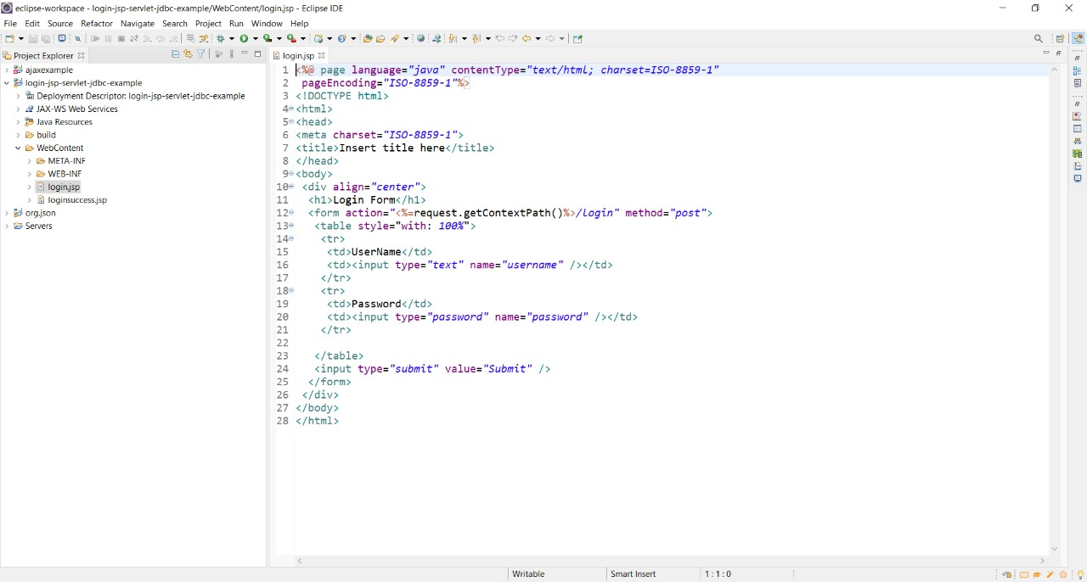

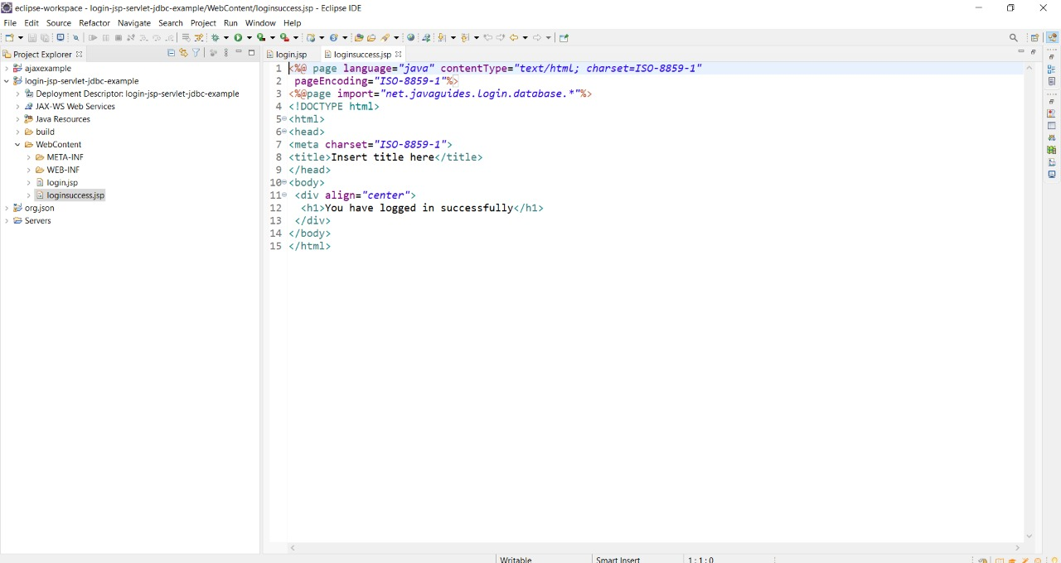

**Output:**

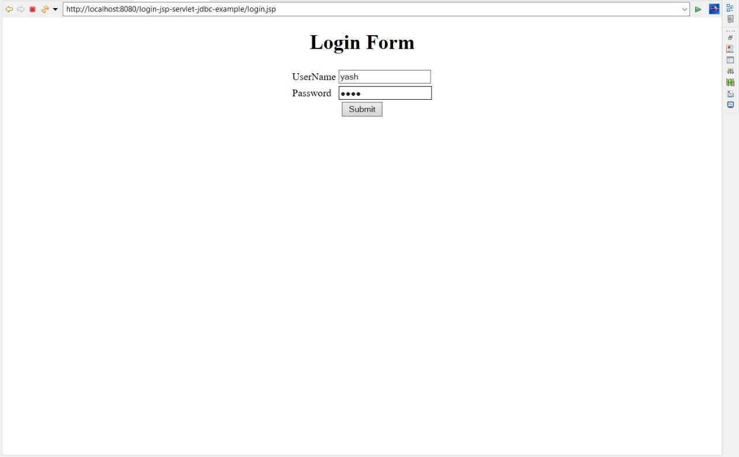

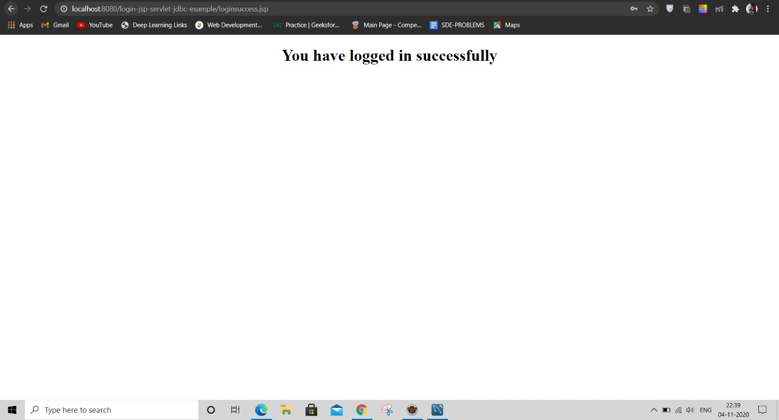

**Result: A simple application for servlet was developed successfully**